Chandru Working..

In this project, we considered two vehicular nodes for secure communication i.e one vehicle node acts as a sender and another node

In this project, there are number of vehicular nodes which are connected to server via TCP/IP. Each node has internal mechanism to gather vehicle status and environmental condition around it. These collected data is encrypted and sent to central server. Each vehicle node will be having authentication key to upload the data which will be prevents the unauthorised entry.

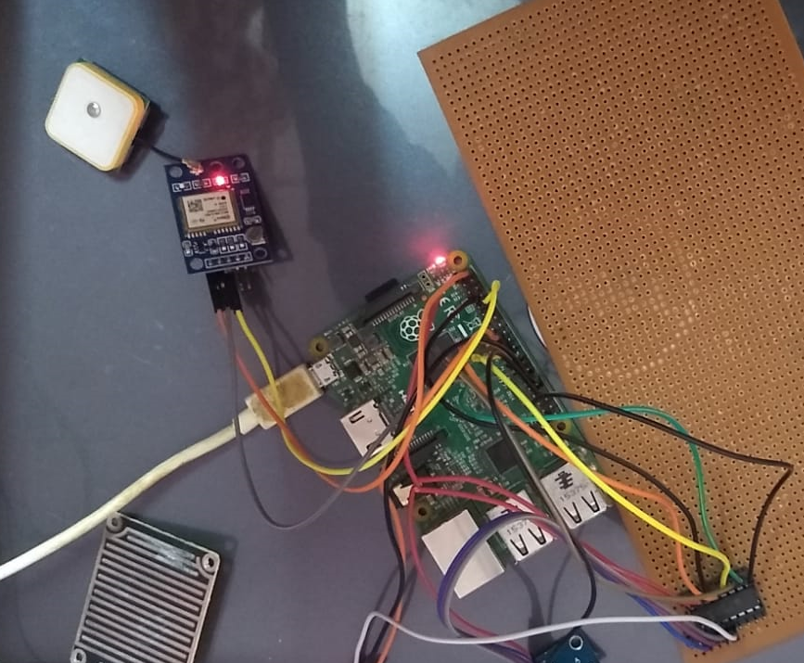

Fig vehicle node set up with Sensors and Raspberry Pi interface

Raspberry pi is the core of individual vehicle node, which acts as data acquisition system. Individual vehicle node consists of various types of analog sensors to predict the status of interior and exterior conditions of vehicle node. It consists of analog accelerometer sensor from which inclination and declination of the road by which condition of the road can be predicted.

The traffic in the area can be determined by brake sensor interfaced with the induvial vehicle node . The period of brake are applied are proportional to the traffic conjunction in that area . Each node will be having in rain sensor attached which to detect the rain surrounding.

These Analog sensors are interfaced to raspberry pi core using s SPI based Protocol based ADC called mcp3008. To detect the location of the vehicle GPS Neo-6M GPS module is interfaced with Raspberry pi core using the UART protocol.

SSD1306 is a single-chip CMOS OLED/PLED driver with controller for organic / polymer light emitting diode dot-matrix graphic display system. It consists of 128 segments and 64commons. OLED is used as dash board to the users to get the information

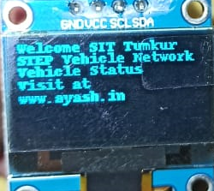

Fig: Information in the OLED to User in the Vehicle node dash baord

For uploading the data from induvial vehicle nodes are done through a cryptographic entry Key. Only indiuvial nodes with key can send the data to central nodes there it avoids unauthorised data entry from hackers like intruder, and pranksters.

The accessing the require data from central database is done through the Public and Private keys. These methods provides

There two types of requests to access the data from the central web server

1. Data access using the Public Key
2. Data access using the private key

Data access using the Public Key

Using the public key only certain data parameters can be accessed from the central server by a vehicle node. This is features ensures of STEPs ensures the following the features of cryptographic techniques are achieved

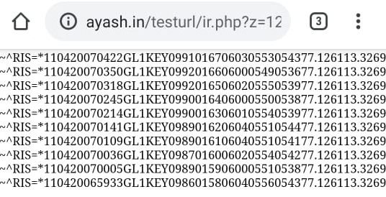

Fig : Data access using the Public Key

* Date integrity
* Security against the Vandal, selfish types of hackers
* Privacy

Data access using the Private Key:

The vehicle can be obtain more data with help of the private key. This scenario will occur when a vehicle node want to access the data based on the location or other major parameter. The main ideology of this method of data access is to provide security against the hacking and accessing the non disclosive data by a unauthorised vehicle node.

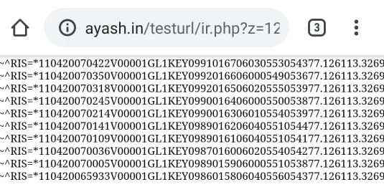

Fig Data access using the Private Key which has more data

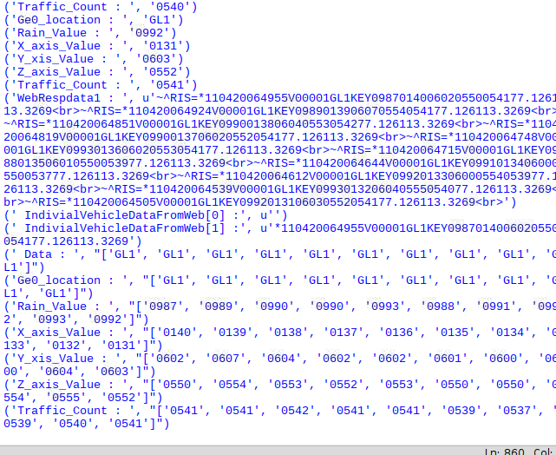

Fig : Data from the website : decryption and data extraction process

Central Authority view :

The central traffic control authority will having the a full access to view and check the data. Data in the website format is shown in the figure bellow.

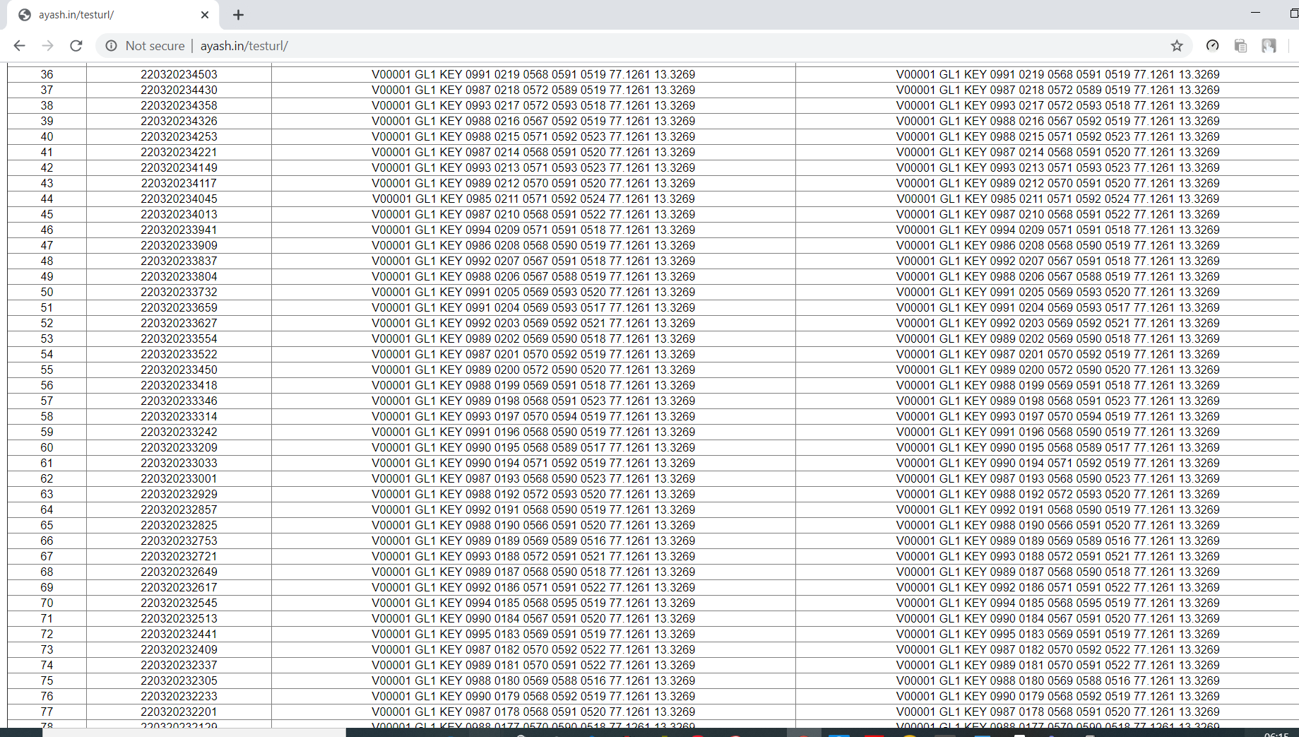

Fig : Data access view to to central authority